CSCI 321 Computer Science III Fall 2018

Lecture 3 Activity 1

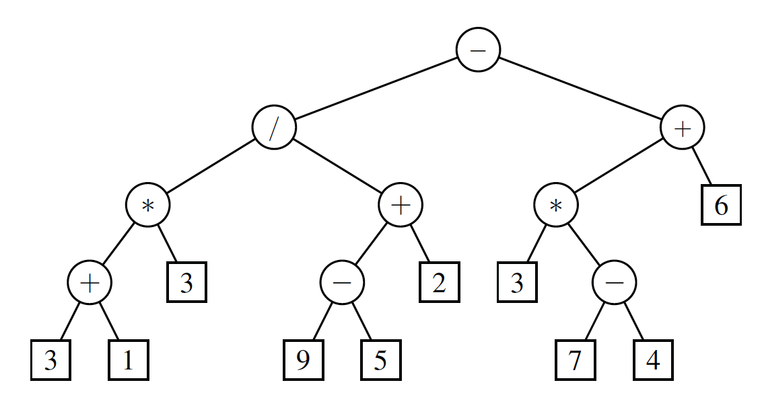

1. (50 points) In what order are positions visited during a ***preorder*** traversal of the tree in Fig 1. Hint: Draw the tree on a separate sheet of paper and then mark nodes as they are visited, writing down the output produced for each visit. Your output should be a sequence like this: “- / * …”.

- / * + 3 1 3 + - 9 5 2 + * 3 – 7 4 6

1. (50 points) In what order are positions visited during a ***postorder*** traversal of the tree in Fig 1. Hint: Draw the tree on a separate sheet of paper and then mark nodes as they are visited, writing down the output produced for each visit. Your output should be a sequence like this: “3 1 + …”.

3 + 1 * 3 / 9 – 5 + 2 – 3 * 7 – 4 + 6